Flying
Historical View of Flying
For centuries man has looked to the sky and with awe wondered what it would be like to fly. We even have some jokes about flying that include other animals. “When pigs fly!” is old expression related to the temperature in Hades getting cold. The implication is that it will never happen.
Note: The Wright brothers were the first humans to fly on December 17, 1903.
Since then many methods of humans flying have occurred. Some are:
Planes
Helicopters
Rockets
Hang Gliders
Things that Fly
Many things fly and the top five as recorded in our fictitious poll include:
Birds
Planes
Insects
Superman
Flags
Impact of Flight on Pets
The People’s Choices
Many people maintain pets and the following table shows the place of birds on the current pet list.
Category | Percent
Dogs | 42%
Cats | 23%
Birds | 14%
Turtles | 4%
Others | 17%
Unique Pet Collections
My unique flying pet is a butterfly.
Here is a hyperlink: http://en.wikipedia.org/wiki/Butterfly
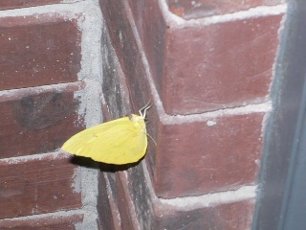
A butterfly’s thoughts:
One cannot entirely trust to flowers that grow in pots," thought the butterfly, "they have too much intercourse with men. I have added some more text to this quote to show how a block quote tag will wrap, indent and italicize the quoted material. Thus, you should not need any quote marks for the block tags.
Crazy
People who keep butterflies as pets and talk to them.

Andersen, Hans Christian; The Ice-Maiden: and Other Tales, pg 169.

