Report1: Diels-Alder and Melting Point(Total 30 points)
Here for the Report

Note: In preparing this report you are free to use references and consult with others. However, you may not copy from other students’ work or misrepresent your own data (see honor code).
Name(Print then sign): ___________________________________________________
Lab Day: ___________________Section: ________TA__________________________
1. Draw the reaction and mechanism of maleic anhydride and cyclopentadiene. (4 points)

2. Show theoretical and percent yield calculations of the reaction between maleic anhydride and cyclopentadiene. (2 points)

3. What are the important IR frequencies and the functional group they correspond to? (2 points)

4. Analyze the NMR spectrum of the product. Draw the structure and assign each peak to the correct proton on the NMR spectrum. Are there any impurities? If yes, what are they? (4 points)

5. Write the major product of the following reactions with proper stereochemistry if required. (8 points)

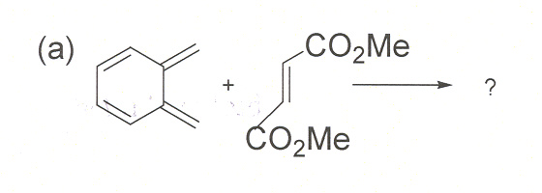
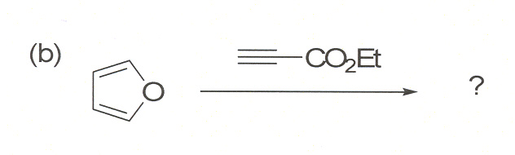
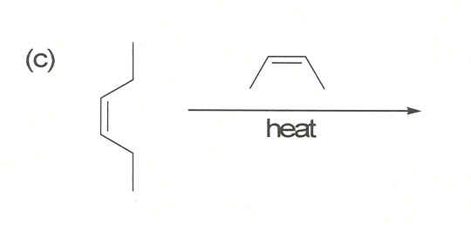
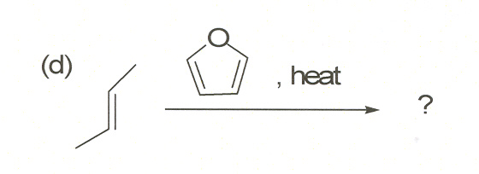

Part 2: Melting Point (Total 10 points)
1. Fill in the blanks: (5 points)
Melting Points of: | Temperature in °C
Urea | _________________________
Cinnamic acid | _________________________
1:9 mixture | _________________________
1:1 mixture | _________________________
9:1 mixture | _________________________

2. Draw a Plot of melting point versus composition of the mixture. (2 points)

3. Your explanation as to why your measured melting points do not match those in literature. (1 point)

4. Identity the unknown (Part II) product. (1 point)

5. Melting point of the DA product is: ____ (1 point)

