Pre-Lab 1: Diels-Alder and Melting Point (Total 10 points)

Here for the Pre-Lab
Name(Print then sign): ___________________________________________________
Lab Day: ___________________Section: ________TA__________________________
This assignment must be completed individually and turned in to your TA at the beginning of lab. Usually, you will not be allowed to begin the lab until you have completed this assignment – allowance made for the first week.
1. The reaction, as you will notice, occurs very rapidly. State two characteristics of the starting materials that make them ideal coupling partners for this reaction (i.e. what are good characteristics for reactants in Diels Alder reactions). (2 points)

2. Write the major product of the following reactions, if there is no product specify why. (4 points)

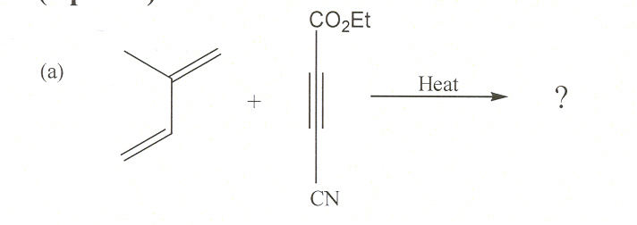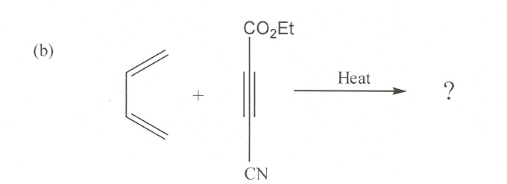

3. a) Which of these dienes gives the FASTEST reaction with maleic anhydride, why? (2 points)

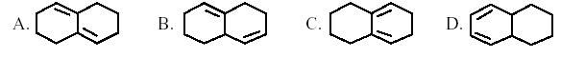

(b) Which of these dienophiles gives the FASTEST reaction with cyclopentadiene and why? (2 points)

